South Sudan resilience baseline

Demographic profiles

Monitoring and Evaluation Support Project (MESP)

Table of contents

# 1 Introduction

# 2 Overall

frq(dat$county)

County of South Sudan (x) <character>   
# total N=7872 valid N=7872 mean=7.01 sd=3.77  
  
Value | N | Raw % | Valid % | Cum. %  
----------------------------------------------  
Akobo | 625 | 7.94 | 7.94 | 7.94  
Baliet | 626 | 7.95 | 7.95 | 15.89  
Budi | 620 | 7.88 | 7.88 | 23.77  
Duk | 518 | 6.58 | 6.58 | 30.35  
Jur River | 611 | 7.76 | 7.76 | 38.11  
Kapoeta North | 603 | 7.66 | 7.66 | 45.77  
Leer | 620 | 7.88 | 7.88 | 53.65  
Mayendit | 606 | 7.70 | 7.70 | 61.34  
Paynijar | 618 | 7.85 | 7.85 | 69.19  
Pibor | 564 | 7.16 | 7.16 | 76.36  
Ulang | 626 | 7.95 | 7.95 | 84.31  
Uror | 616 | 7.83 | 7.83 | 92.14  
Wau | 619 | 7.86 | 7.86 | 100.00  
<NA> | 0 | 0.00 | <NA> | <NA>

table(dat$region, dat$county)

Akobo Baliet Budi Duk Jur River Kapoeta North Leer Mayendit  
 Bahr-El-Ghazel 0 0 0 0 611 0 0 0  
 Equatoria 0 0 620 0 0 603 0 0  
 Great Upper Nile 625 626 0 518 0 0 620 606  
   
 Paynijar Pibor Ulang Uror Wau  
 Bahr-El-Ghazel 0 0 0 0 619  
 Equatoria 0 0 0 0 0  
 Great Upper Nile 618 564 626 616 0

# 3 Jur River (Bahr el Gazal)

jur <- dat %>%  
 filter(county=="Jur River")  
  
hhjur <- hh %>%  
 filter(county=="Jur River")

## 3.1 Age

#frq(hhjur$sex)  
  
#hhjur <- hhjur %>%  
# mutate()  
  
#age_jur <- data.frame(table(hhjur$age_dec, hhjur$sex))  
  
 age_jur <- hhjur %>%  
 group_by(age_dec, sex) %>%  
 summarize(sex_count=n()) %>%  
 left_join(age_dec_key) %>%  
 left_join(sex_key) %>%  
 mutate(count=ifelse(sex_lab=="Male", sex_count, sex_count*-1)) %>%  
 na.omit()

Error in `group_by()`:  
! Must group by variables found in `.data`.  
x Column `age_dec` is not found.

age_jur

Error in eval(expr, envir, enclos): object 'age_jur' not found

ggplot(age_jur, aes(age_lab, count, fill=sex_lab)) +  
 geom_bar(stat="identity", alpha=.8, width=.6) +  
 scale_fill_manual(values=c("dodgerblue2","maroon")) +  
 coord_flip() +  
 #scale_y_continuous(labels=age_dec_key$age_lab) +  
 theme(legend.title=element_blank(),  
 legend.position="bottom",  
 axis.ticks.x=element_blank(),  
 axis.text.x=element_blank()) +  
 labs(x="",  
 y="",  
 title="Age pyramid\nJur River")

Error in ggplot(age_jur, aes(age_lab, count, fill = sex_lab)): object 'age_jur' not found

ggplot(hhjur, aes(age)) +   
 stat_density(fill="dodgerblue2", alpha=.5) +   
 geom_vline(xintercept=mean(hhjur$age, na.rm=T), color="darkgoldenrod2", size=1) +  
 scale_x_continuous(breaks=seq(0,80,10)) +  
 theme(axis.text.y=element_blank(),  
 axis.ticks.y=element_blank()) +  
 labs(x="",  
 y="",  
 title="Age, Jur River")

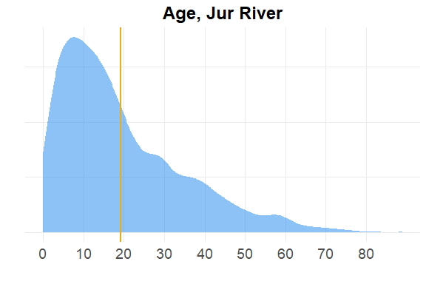

## 3.2 Literate

hhjur %>%  
 filter(age>5) %>%  
 describe(literate)

Error in describe(., literate): object 'literate' not found

## 3.3 Economic activity in last 10 years (Q314)

jur_ec <-ec_act_cnty_lst$`Jur River` %>%  
 arrange(desc(freq))

Error in arrange(., desc(freq)): object 'ec_act_cnty_lst' not found

jur_ec

Error in eval(expr, envir, enclos): object 'jur_ec' not found

jur_314 <- data.frame(frq(hhjur$q_314)) %>%  
 select(2:4) %>%  
 na.omit() %>%  
 arrange(desc(frq)) %>%  
 mutate(percent=round(frq/sum(frq),3),  
 rank=rev(rank(frq)))  
  
jur_314_gt <- jur_314 %>%  
 select(-1, Income=2) %>%  
 gt()   
  
jur_314_gt

## 3.4 Livelihood activities (Q401-Q402)

jur_inc <- inc_cnty_lst$`Jur River`

Error in eval(expr, envir, enclos): object 'inc_cnty_lst' not found

jur_inc

Error in eval(expr, envir, enclos): object 'jur_inc' not found

## 3.5 Wau (Bahr el Gazal)